**Hyland Hills Gymnastics CARA State Meet Schedule**

**Location:** Hyland Hills Sports Center – 4201 W. 94th Ave, Westminster, CO, 303-650-7500

**Dates:** July 26th – July 28th, 2024

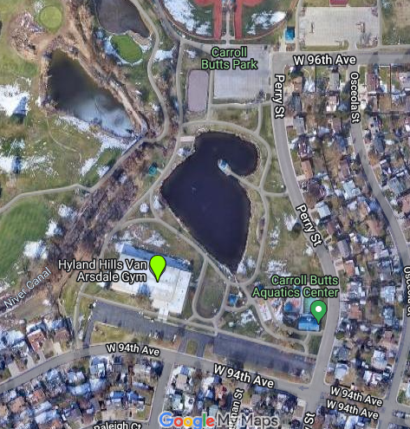

Park Here

Park Here

Park Here

**Admission Fee:** $10 age 2 and up per session, $25 all day

**Important Information:**

* Please note that parking is only permitted in the designated areas on the pictured map. ***Do not park on the residential side of the streets!***
* Do not arrive before your scheduled time.
* We will provide a concession stand with a variety of items.
* Candygrams will be available for purchase.

**Session Schedule:**

**FRIDAY, JULY 26th**

**Session 1** – Optional 1 – Ages 7-9 and 12-13

Arrive: 7:45am

Stretch: 7:45 – 8:05am

First Event Warm Up: 8:05-8:20am

March In: 8:25am

Competition 8:30-10:30am

Awards: 10:30am-11:00am

**Session 2** – Optional 2 – Ages 7-12 and Optional 3 - All ages

Arrive: 10:45am

Stretch: 10:45-11:15am

First Event Warm Up: 11:15-11:30am

March In: 11:35am

Competition: 11:40-2:00pm

Awards: 2:00-2:30pm

**Session 3** – Optional 1 – Ages 10-11 and Optional 1 – Ages 14+

Arrive: 2:15pm

Stretch: 2:15-2:45pm

First Event Warm Up: 2:45-3:00pm

March In: 3:05pm

Competition: 3:10-5:30pm

Awards: 5:30-6:00pm

***\*Mandatory CARA League for coaches 6:30-8:30pm\****

**SATURDAY, JULY 27th**

**Session 4** – Optional 2 – Ages 13-18 and Optional 4 - All ages and Optional 5 - All ages

Arrive: 7:45am

Stretch: 7:45 – 8:15am

First Event Warm Up: 8:15-8:30am

March In: 8:35am

Competition 8:40-11:00am

Awards: 11:00-11:30am

**Session 5** – Compulsory 4 – Ages 7-10 and 14+

Arrive: 11:00am

Stretch: 11:00-11:20am

First Event Warm Up: 11:20-11:35am

March In: 11:40am

Competition: 11:45am-3:00pm

Awards: 3:00-3:30pm

**Session 6** – Compulsory 4 – Ages 11-13 and Super Comp 4s – All ages

Arrive: 3:00pm

Stretch: 3:00-3:15pm

Frist Event Warm Up: 3:15-3:30pm

March In: 3:35pm

Competition: 3:40-5:45pm

Awards: 5:45-6:15pm

**Session 7** – Compulsory 3 – Ages 11+

Arrive: 5:45pm

Stretch: 5:45-6:00pm

Frist Event Warm Up: 6:00-6:15pm

March In: 6:20pm

Competition: 6:25-8:30pm

Awards: 8:30-9:00pm

**SUNDAY, JULY 28th**

**Session 8** – Compulsory 3 – Ages 7-8 and 10 and Super Comp 3s – All Ages

Arrive: 8:30am

Stretch: 8:30-8:45am

Frist Event Warm Up: 8:45-9:00am

March In: 9:05am

Competition: 9:10-11:15am

Awards: 11:00-11:30am

**Session 9** – Compulsory 2 - Ages 7-10

Arrive: 11:30am

Stretch: 11:30-11:45am

Frist Event Warm Up: 11:45-12:00pm

March In: 12:05pm

Competition: 12:10-2:30pm

Awards: 2:30pm

**Session 10** – Compulsory 3 - Age 9 and Compulsory 2 – Ages 11+ and Super Comp 2s – All ages

Arrive: 2:15pm

Stretch: 2:15-2:30pm

Frist Event Warm Up: 2:30-2:45pm

March In: 2:50pm

Competition: 2:55-6:00pm

Awards: 6:00-6:30pm